**Part 2: Static Acquisition** (3 marks)

**Course Name**: FRS301-Digital Forensics

**Student Name**: Nguyễn Trần Vinh – SE160258

**Instructor Name**: Lê Tiến Dũng

**Lab Due Date**: 28/2/2023

## What You Need for This Project

* VMware Workstation
* Any other tools you choose to use

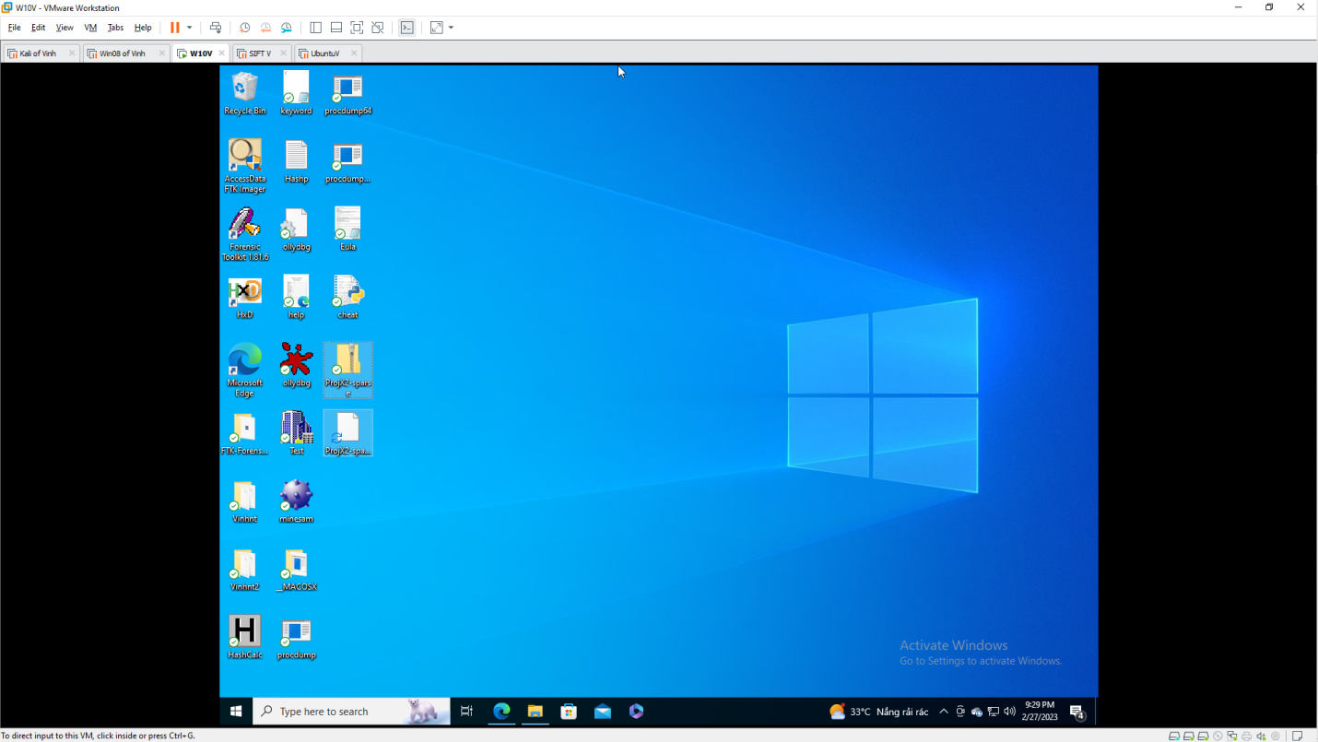

## Getting the Evidence File

1. Download **ProjX2-sparse.zip** file
2. Calculate the MD5 hash of the file and verify that it matches the value shown to the right on this page.

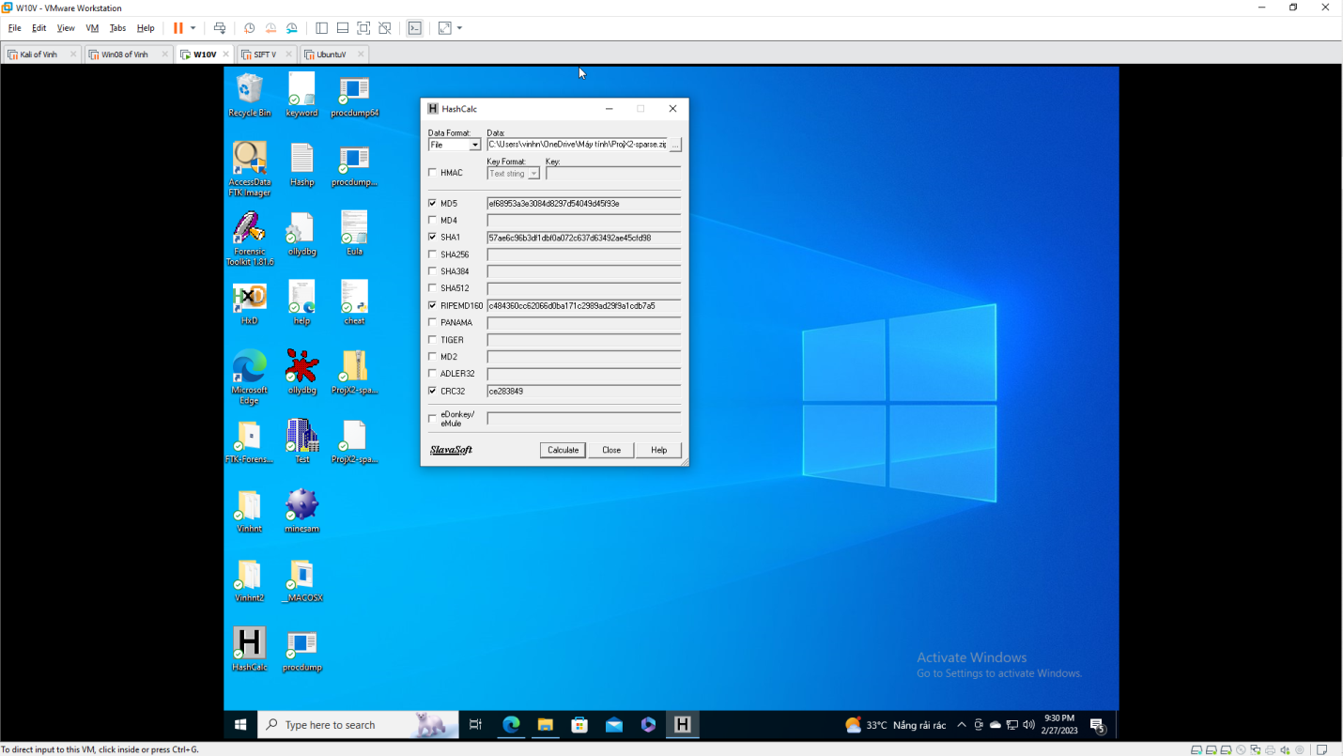

1. Unzip the file to extract the virtual hard disk inside.

## Imaging the Evidence Drive

1. Mount the evidence drive in an appropriate virtual machine.
2. Use any technique you like to make a correct forensic image of the drive.
3. Calculate the MD5 hash of your forensic image.

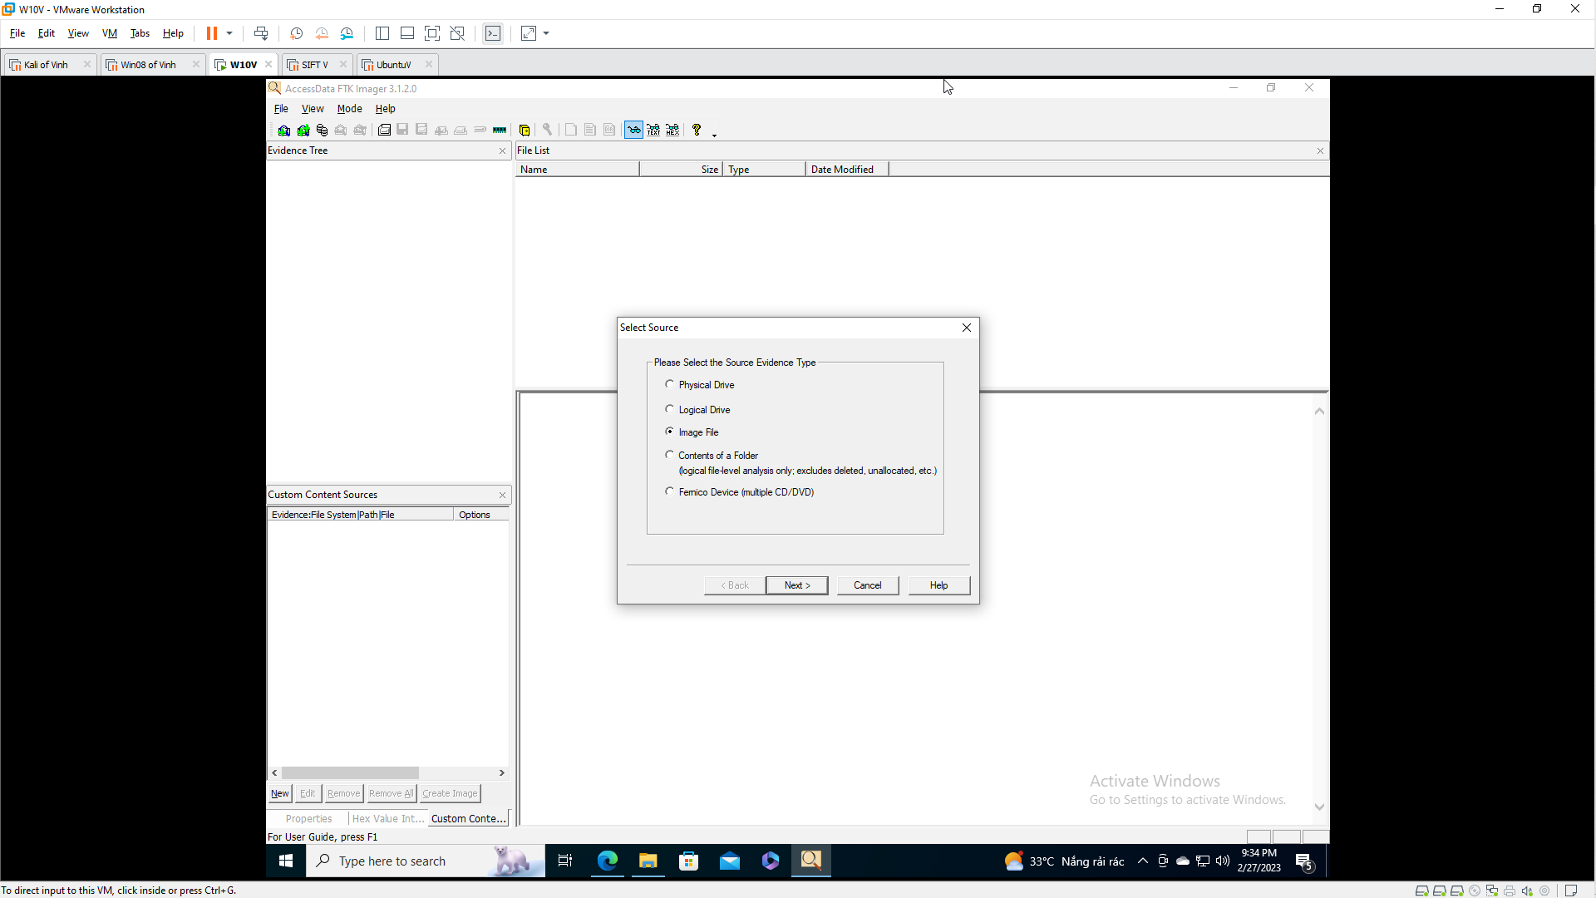 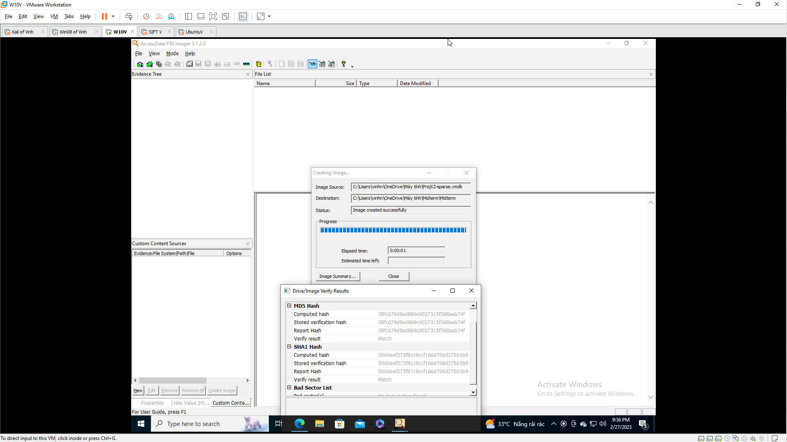 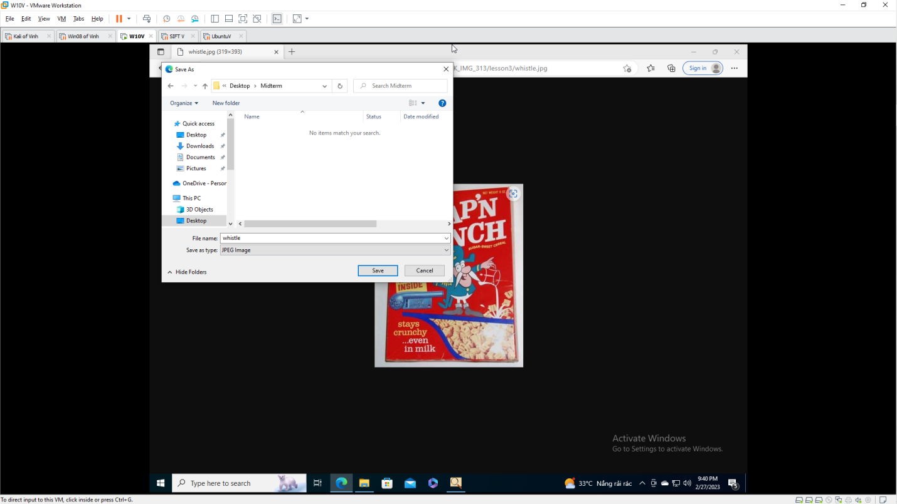

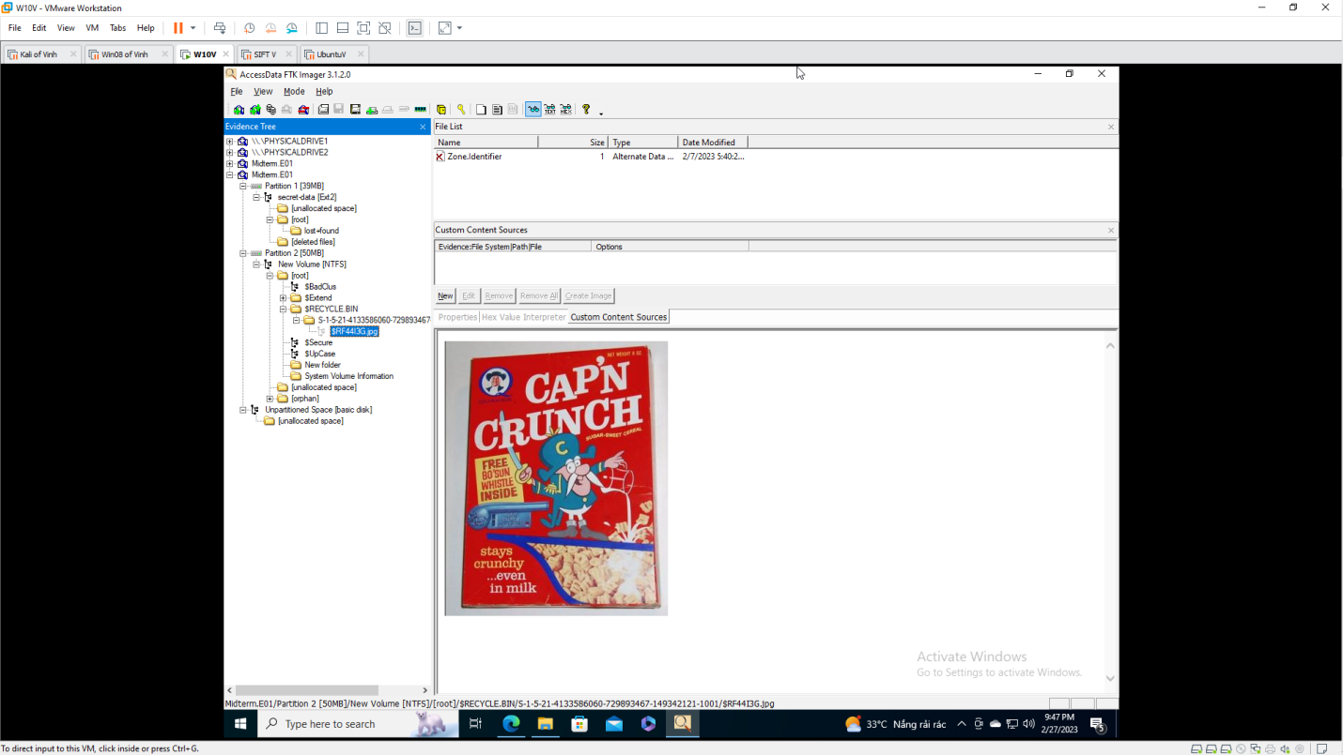

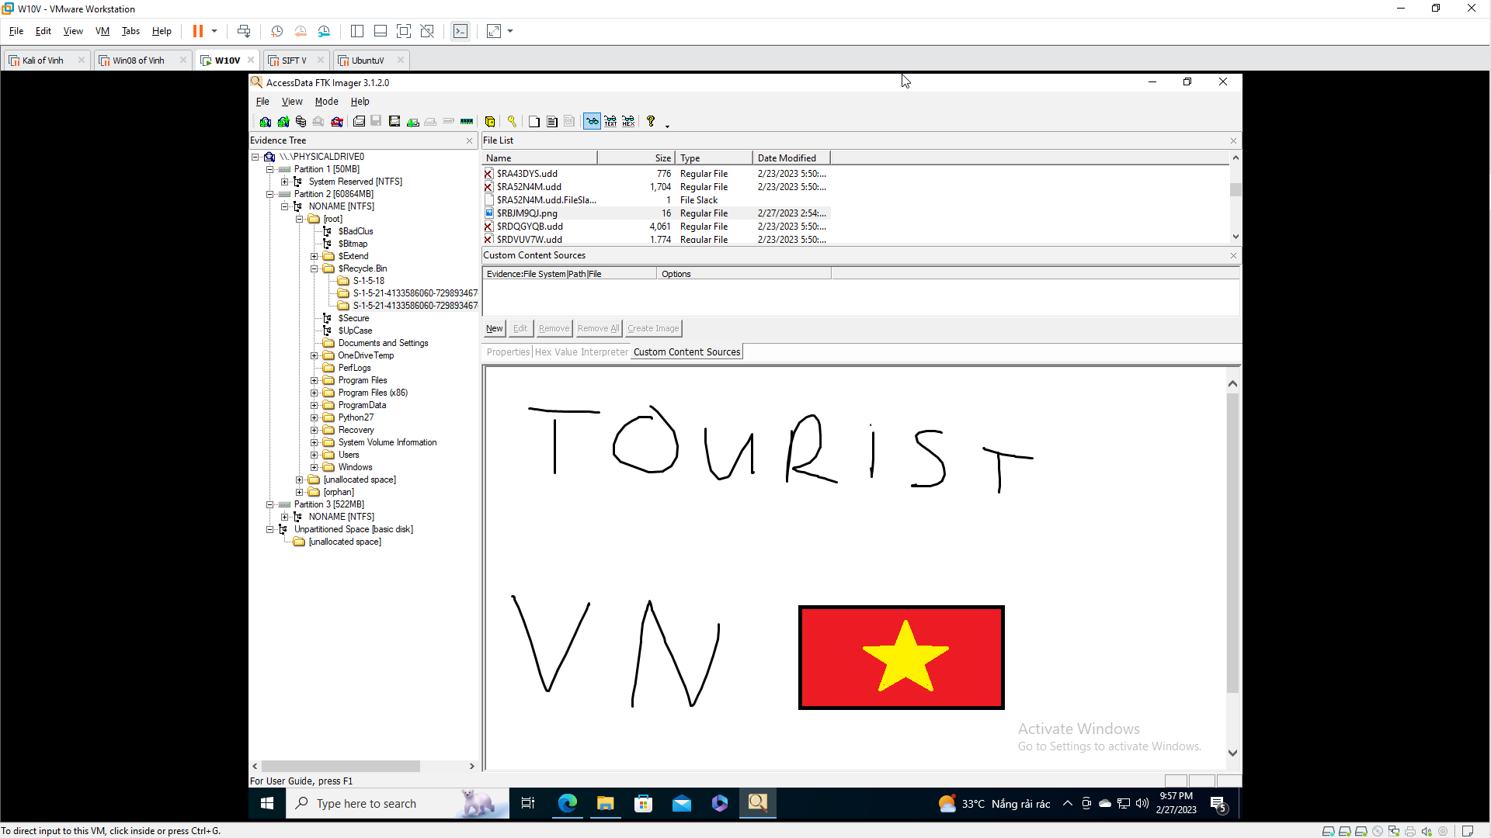

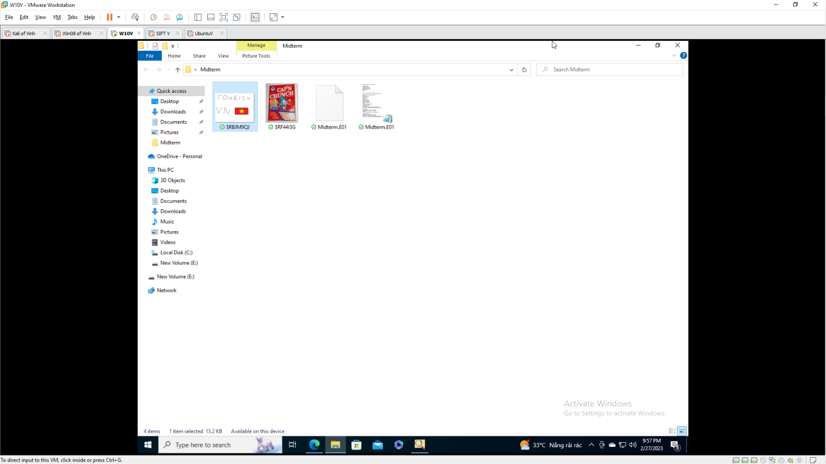

## Saving a Screen Image

Make sure your screen shows the MD5 of the image, from whatever tool you chose to use.